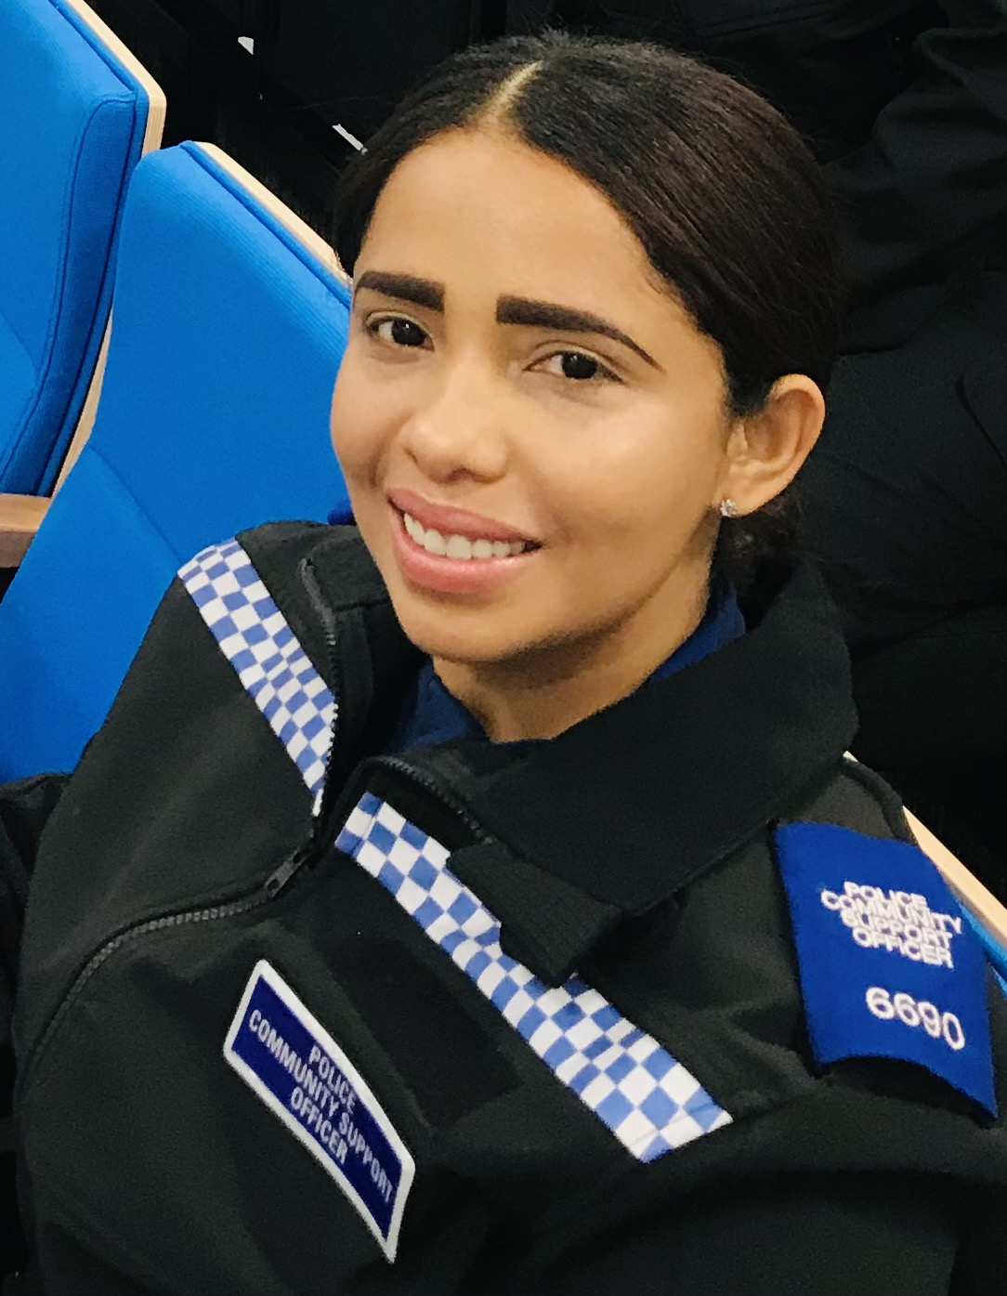

March / 2021
Chard Town
Our new PCSO
From training School to Yeovil and now landing in Chard. Our new Chard Town Police Community Support Officer.

Introducing our new Chard Town PCSO, Luiza or Lou for short. Luzia comes from Brazil and is fluent in Portuguese. Being fluent in Portuguese will help to build our relationship with our Portuguese communities. Luiza was a coordinator for an Electrical Company before joining the Police. Joining the Police has always been something that Luzia has wanted to do, ever since she lived in Brazil.

Meet our Supervisors

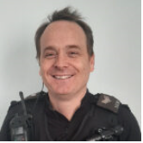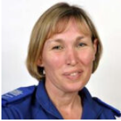

Pictured above from left:

Police Sergeant Robert Jameson and Police Community Support Officer Supervisor Michelle Haimes

Our Sergeant and Supervisor cover more than just Chard. They also cover Ilminster and Crewkerne.

www.avonandsomerset.police.uk/your-area to see your area and what Neighborhood Team cover you.
Operation Surge
March / 2021
Chard, Ilminster and Crewkerne
Operation Surge has been funded with money from the Home Officer to help combat violent crime. Officers have undertaken high visibility patrols in key areas.

Over the last few months our officers around the local area have been participating in Operation Surge. The force has used funding to fund extra shifts to enable officers to help and support their local areas that may be affected by violent crime.

Many positive actions come from Op Surge such as; arrests, seized vehicles, vulnerable victim visits, cuckooing visits and stop searches.

Neighbourhood Teams

The local Neighborhood Teams continues to work together with our communities and tackle the issues with vehicles being untaxed, uninsured and without MOT’s

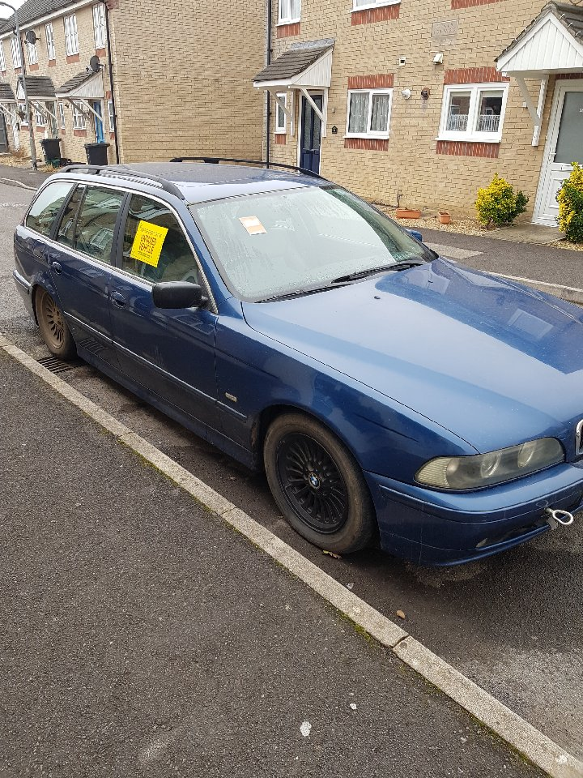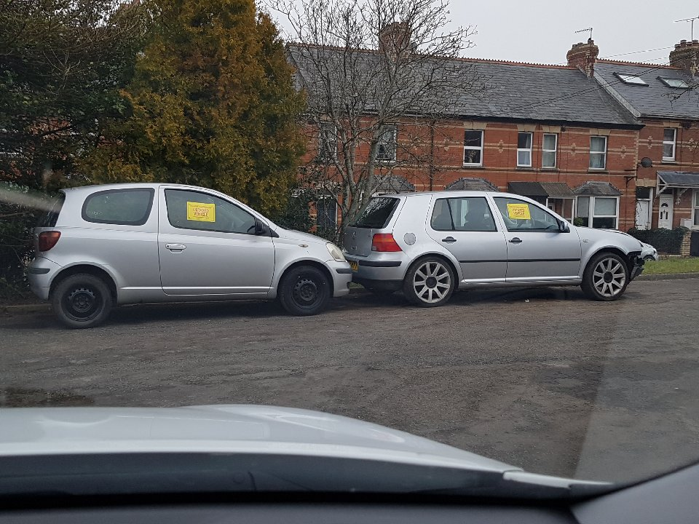

Positive actions

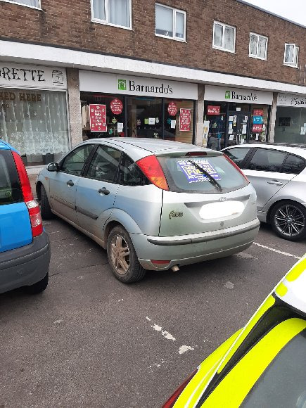
Car Seized

During our Op Surge patrols stopped a vehicle driven by a disqualified driver. The vehicle had no insurance and was subsequently seized by Police.

3 Arrested

During Op Surge patrols, officers came across a vehicle that was stopped for routine checks. This lead to a foot chase which subsequently lead to 3 arrests for Possession with Intent to supply Class A drugs.

Crewkerne Fire
March / 2021
Crewkerne

On the 22nd of February 2021 a fire was started at former NatWest Bank. 14 Fire engines were called to the tackle the fire.

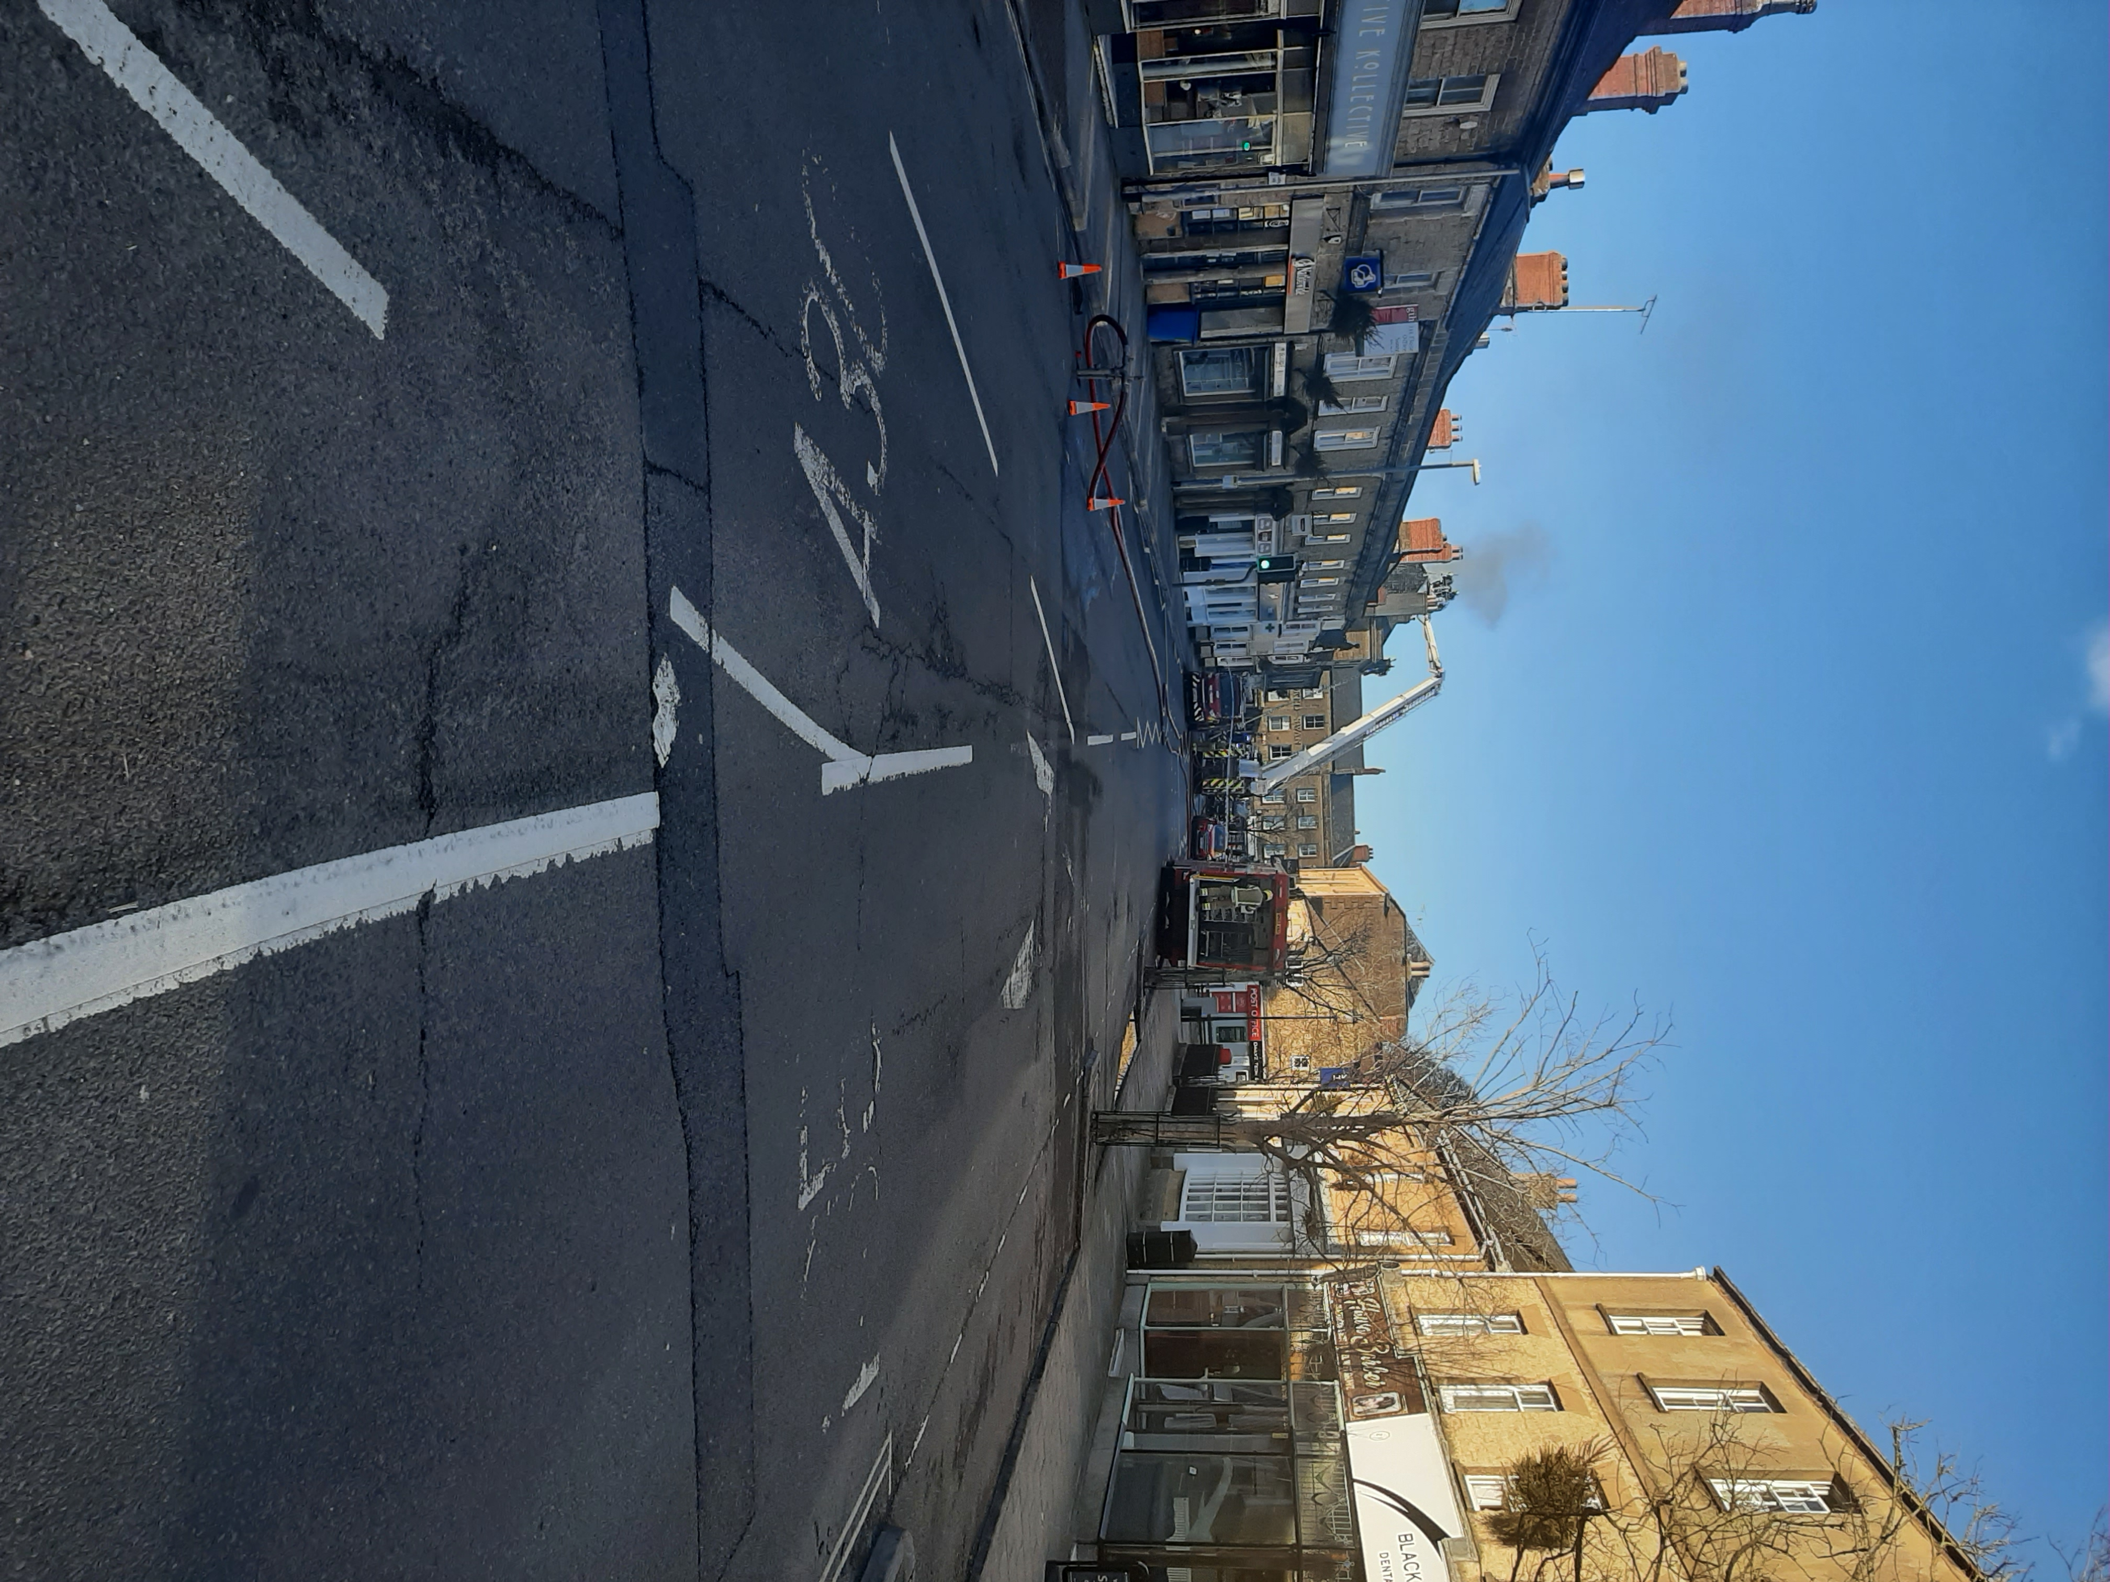

14 fire engines were called to the scene along with other emergency services. As a result, there were many road closures and parts of the town centre were closed to pedestrians, causing local business to close.

Fire worked tirelessly for many hours before they managed to scale down their operation just after 5pm.

Thank you

During the incident many people gathered and we would like to thank everybody who listened to the Polices instructions to disperse due to the smoke and COVID concerns. .

We would also like to pass on our thanks to the local businesses who supplied the officers and emergencies services with refreshments during fire in Crewkerne. Everything that was donated to assist the crews dealing with the incident was well received and appreciated by all the emergency services

Follow us on Social Media

Follow us on our social media platforms below;

Facebook - https://www.facebook.com/aspsouthsomerset/

Twitter - https://twitter.com/ASPSouthSom

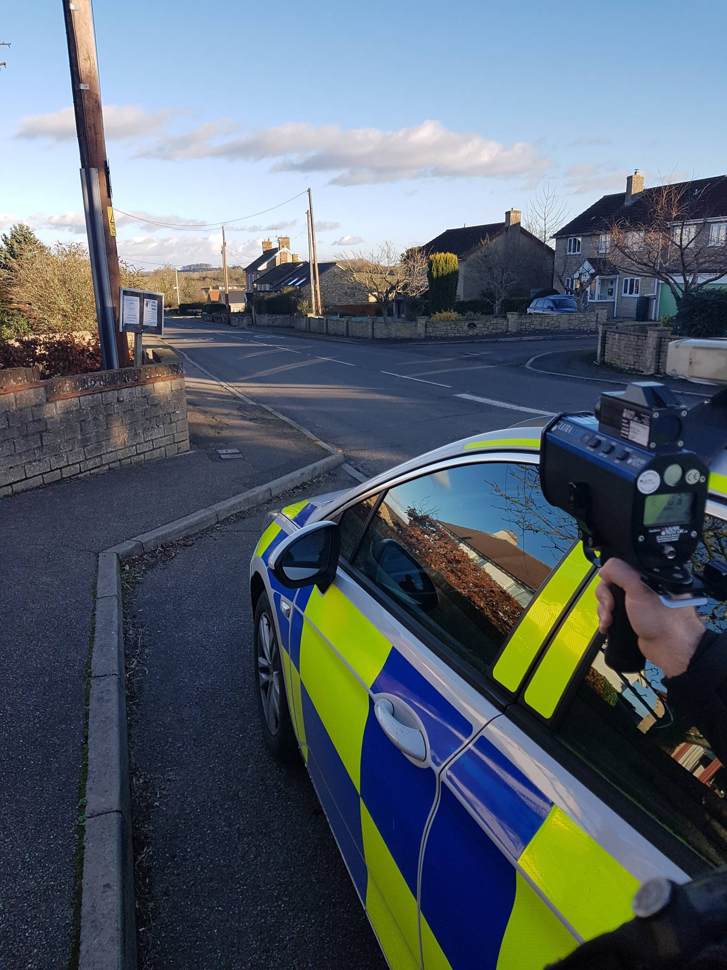

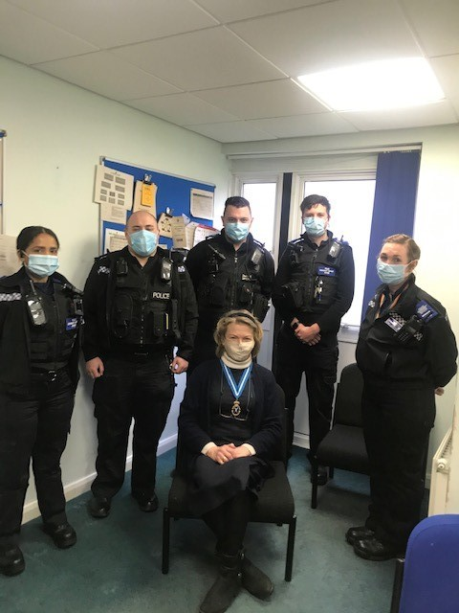
Operation Shogun
PCSO Allington Cycle Patrols

PCSO Allington has been out and about on his rural patrols using his new Police bike.

March / 2021
Rural

Shogun is our Rural Operation which helps to prevent crimes related to agricultural equipment, Farmland and Livestock.

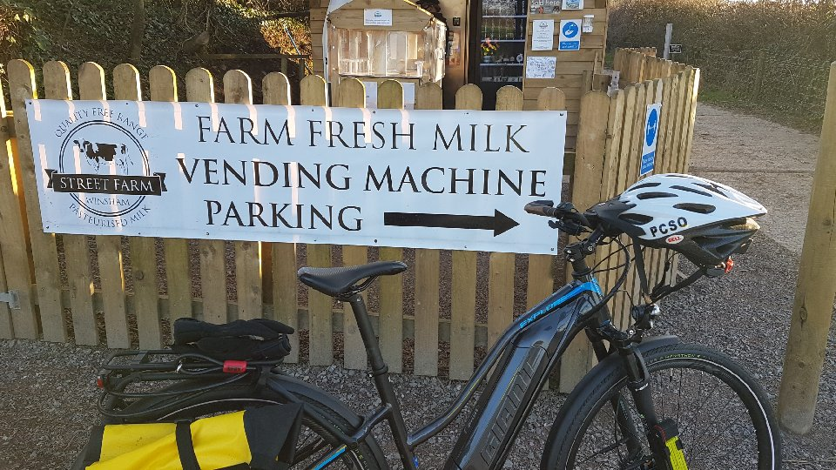
Over the coming days and weeks our officers will be participating in Operation Shogun. Shogun works closely with our neighbouring forces along our boarders. Officers from Avon and Somerset and Devon and Cornwall will be out actively patrolling key areas and stopping vehicles for routine checks.

Rural Affairs Team

Our team have been working closely with the Rural Affairs unit over the last few months. This team is dedicated to tackle rural crime and issues such as farm machinery thefts, livestock thefts, poaching including hare coursing. They also gather information on the criminal groups who are involved in targeting our farmers and rural communities. . We have been attending farms and small holdings throughout our area in order to sign farmers up to the Farm Watch scheme. If you are not aware of how Farm Watch works please visit the Avon and Somerset Website and click on ruralandwildlifeunit@avonandsomerset.police.uk. Alternatively please ring 101 and ask to speak to your local neighbourhood team.

Neighbourhood Team Rural Officers;

Chard – Gareth Allington 8506
Ilminster – John Martin 8391 & Stephen Trace 6517
Crewkerne – Wesley Ashbrook 8203

